Lab 4 Python Basics

Name: Ketan Goud
Reg No: 220905260
Roll No: 39
Section: CSE D D2

1. Write a python program to reverse a content a file and store it in another file.

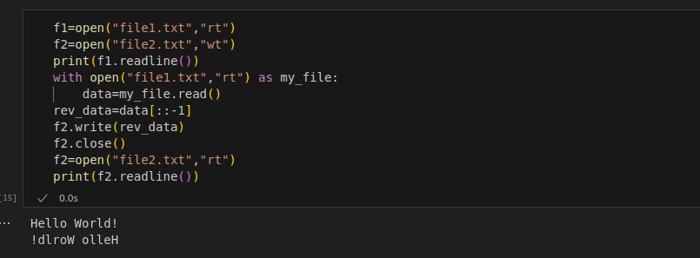
2. Write a python program to implement binary search with recursion.

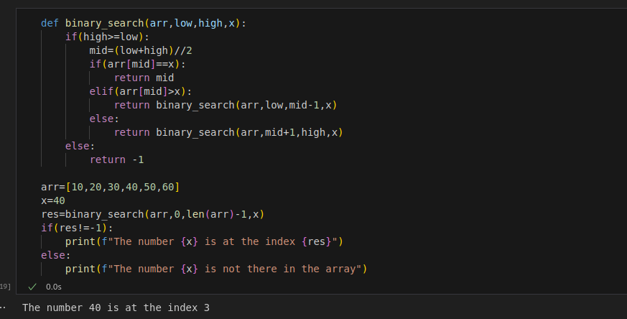

3. Write a python program to sort words in alphabetical order.

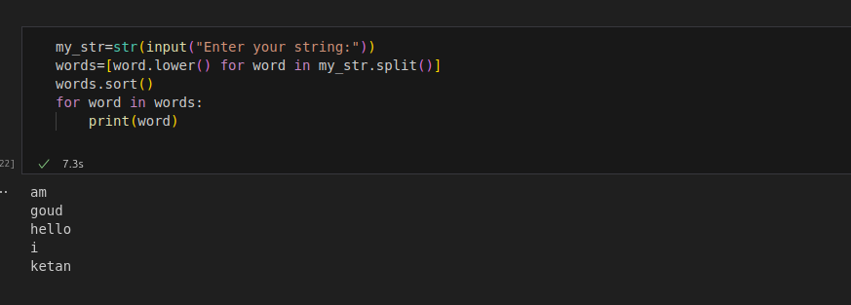

4. Write a Python class to get all possible unique subsets from a set of distinct
integers Input:[4,5,6]
Output : [[], [6], [5], [5, 6], [4], [4, 6], [4, 5], [4, 5, 6]]

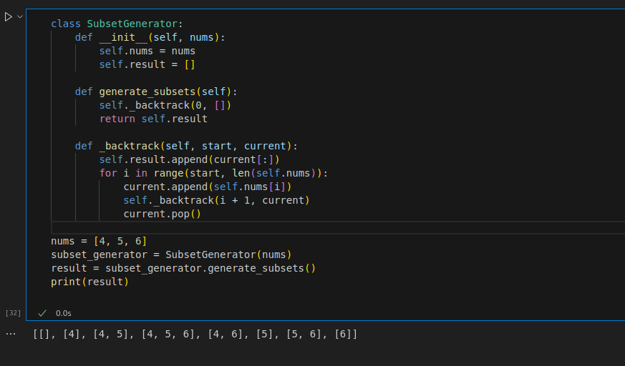

5. Write a Python class to find a pair of elements (indices of the two numbers)
from a given array whose sum equals a specific target number.
Input: numbers= [10,20,10,40,50,60,70], target=50
Output: 3, 4.

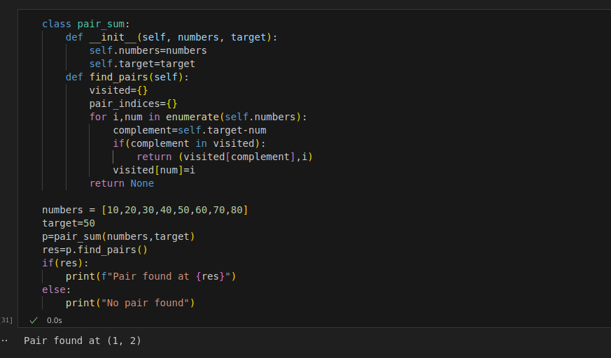

6. Write a Python class to implement pow(x, n).

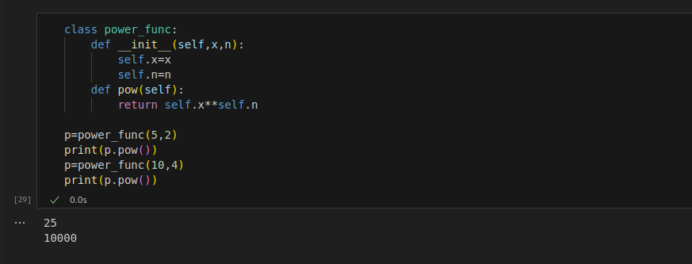

7. Write a Python class which has two methods get_String and print_String. The
get_String accept a string from the user and print_String print the string in upper
case.

